**Рівень 1-2.**

**Bug 1.**

**Title:**

UI/UX: The footer links are out of the logic order

Environment:

1. Firefox 110.0 (64-bit)
2. 109.0.5414.120 (64-bit)
3. Microsoft Edge 110.0.1587.50 (64-bit)

Priority: low

**STR:**

1 Visit https://odessa.oxford-med.com.ua/ua/#

2 Scroll down the page until you reach the footer

3 Pay attention to the .footer_nav in the footer

**AR:** the links in the footer looks messy without any clear order

**ER:** the links in the footer should be properly ordered so it's easy to navigate through them

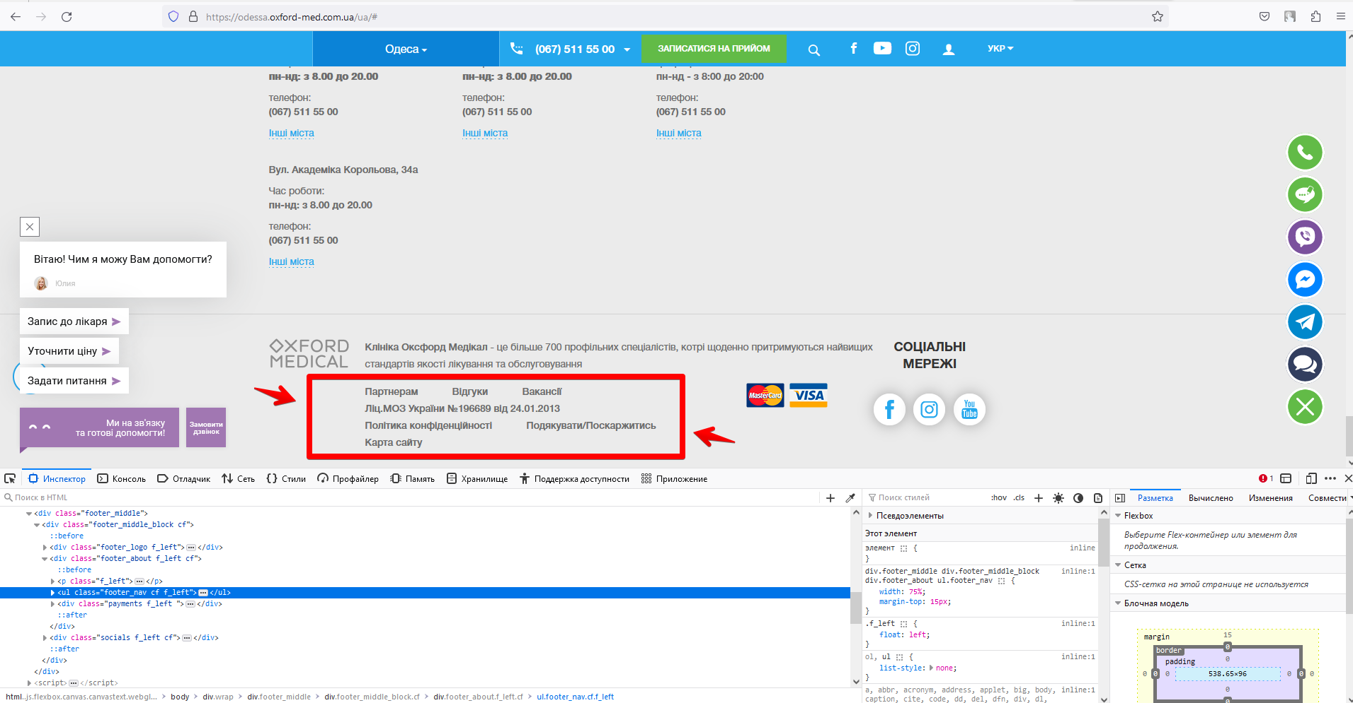

**—-----**

**Bug 2.**

**Title:**

UI: The dropdown table pointer in the main menu appears under the incorrect button

Environment:

* Firefox 110.0 (64-bit)
* 109.0.5414.120 (64-bit)
* Microsoft Edge 110.0.1587.50 (64-bit)

Priority: low

**STR:**

1 Visit https://odessa.oxford-med.com.ua/ua/

2 Press the "ВІДДІЛЕННЯ" button

**AR:** The table pointer is under the button "ПРО МЕДИЧНИЙ ЦЕНТР"

**ER:** The table pointer is under the button "ВІДДІЛЕННЯ"

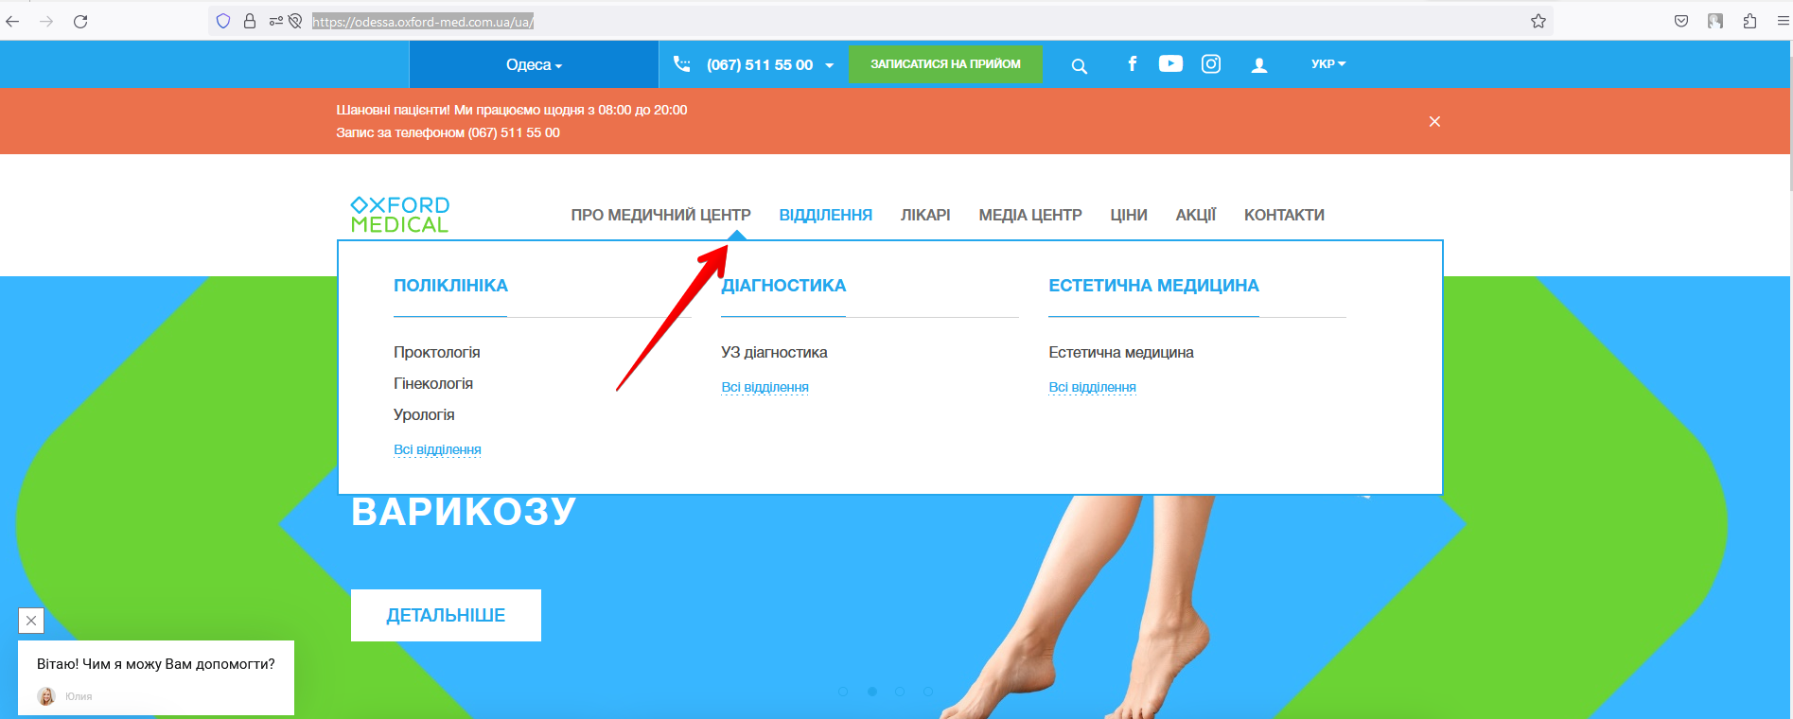

**—---**

**Bug 3.**

**Title:**

UX: The language selector's dropdown menu does not automatically disappear after moving the mouse out

Environment:

* Firefox 110.0 (64-bit)
* 109.0.5414.120 (64-bit)
* Microsoft Edge 110.0.1587.50 (64-bit)

Priority: low

**STR:**

1 Visit https://odessa.oxford-med.com.ua/ua/

2 Hover your mouse over the language dropdown selector

3 Change the mouse position so it doesn't touch the recently opened language selection dropdown

4 Check the results

**AR:** The menu keeps appearing after moving the mouse to another place

**ER:** The menu disappears after moving the mouse to another place

Video reproduce:

<https://drive.google.com/file/d/1vK_dH_od62zeS_iseIpq03SgJiJUl7TQ/view?usp=share_link>

**—---**

**Bug 4.**

**Title:**

UX: The clinic info page does not include direct links to visit a specific department

Environment:

* Firefox 110.0 (64-bit)
* 109.0.5414.120 (64-bit)
* Microsoft Edge 110.0.1587.50 (64-bit)

Priority: low

**STR:**

1 Visit https://odessa.oxford-med.com.ua/ua/o-klinike/#

2 Scroll down the page until you reach the section "Про медичний центр Оксфорд Медікал Одеса"

3 Pay attention to the list of clinic departments

**AR:** It's not possible to click the department name and visit the info page related to this specific department

**ER:** It should be possible to click in the department name and visit the related page on the site, for example:

Press "Дерматологія" -> Redirect to

<https://odessa.oxford-med.com.ua/ua/services/dermatology/>

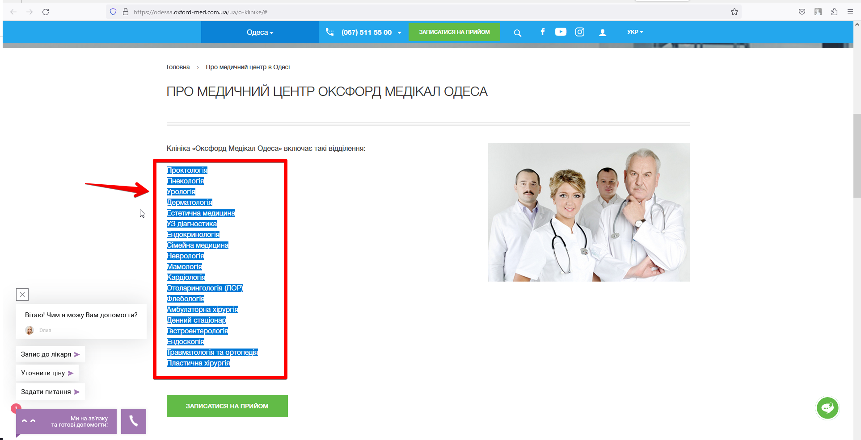

**—---**

**Bug 5.**

**Title:**

UI/UX: Excessive buttons in the footer

Environment:

* Firefox 110.0 (64-bit)
* 109.0.5414.120 (64-bit)
* Microsoft Edge 110.0.1587.50 (64-bit)

**Description:**

The issue is related to using the "Всі відділення" button under the different services sections.

If we press "Всі відділення" under the "ДІАГНОСТИКА" section, the menu will display only 1 more additional option to select.

If we press "Всі відділення" under the "ЕСТЕТИЧНА МЕДИЦИНА" section, the system will not display additional options at all.

These buttons are excessive and can be removed, on the other hand, the page can be adjusted and instead of using the "Всі відділення" buttons we can simply add more buttons with direct links and extend the vertical menus.

**STR:**

1 Visit https://odessa.oxford-med.com.ua/ua/o-klinike/#

2 Scroll down the page until you reach the footer

3 Pay attention to the "ДІАГНОСТИКА" section

4 Press "Всі відділення" button and check the results

**AR:** The newly appeared menu displays only 2 available options, one of which was available on the initial menu

**ER:** The button "Ендоскопія" should appear right under the "УЗ діагностика" and "Всі відділення" should not appear in this vertical menu

*PS. the same case should be fixed for "Естетична медицина"*

**Video:** <https://drive.google.com/file/d/10RK9lQu_Dw9XqtXBGqVCnoNn3WNNuomr/view?usp=share_link>

**Рівень 3**

* **Номер телефону у хедері**

шрифт: HelveticaNeue-Bold, sans-serif;

розмір: 16px/24px

колір: #fff;

бекграунд колір: #24a7ed;

* **ім’я асистента при виклику чата допомоги**

шрифт: Roboto, sans-serif;

розмір: font-size: inherit;

колір: inherit;

бекграунд колір: unset

* **кнопка “інші міста” у футері сайту**

шрифт: HelveticaNeue, sans-serif;

розмір: 14px/24px

колір: #24a7ed;

бекграунд колір: none

* **Placeholder “ім’я” у формі “ЗАПИСАТИСЯ НА ПРИЙОМ”**

шрифт: HelveticaNeue, sans-serif

розмір: 14px/18px

колір: #6d6d6d;

бекграунд колір: field